**ADVANCED JAVA PROGRAMMING PROJECTS**

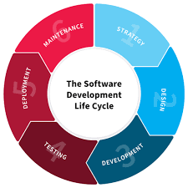

**NAME: MUJAWIMANA DELPHINE**

**REG NO: 221011707**

**CLASS NO: GROUP2**

**PROJECT NAME: E-WALLET**

1. **PLANNING**

**About my project:**

My project called E wallet refer to a software ,an electronic device or an online service that enables individual or businesses to make transaction by using smart phones and computer.

**Objectives and goals of my project**

E- Wallet objectives ad goals are:

* Reduce to carry money physical by avoiding loss of money and to be stolen.
* To make paperless money transaction for helping people to use their banks whenever they are.

**Problem to be solved by using e wallet**

* Traditional wallet ,people don’t have to wait it long transaction ,which onlt cost lots of time and effort
* Easy bill payment ,this will allow everyone wants to pay their bills including fees, rent, tickets, and other utilities with a single click on their smart phones and computer.
* Another problem solved is that it doesn’t need bank account for transaction
* Another solution is that for this generation it’s is not good to carry money everywhere you go for avoiding risks so cashless is a good solution especially e wallet.
* This is a best solution for being safe because all transaction made by e- wallet is safe no more worries of using traditional way that coursed to be stolen.
* E wallet do not charge any cost for the users it’s a free service and e wallet used to transfer money from one person to another.

1. **DESIGN**

**The way this stage was conducted. Ensuring that everything works as expected. and which defect and debugs found and how did I fixed them to ensure that the product meets the original specification.**

How I designed my e wallet can make a user to full fill registration form that contains many details of a user and sign up, after sign up users have an account on my system. after when he/she want to use it her/ his account can login by using username and password only. so our interface was a guider of what we provide to our client, and it contains 6 menus, like my wallet menu for looking how much money she/he have and depositing menu by deposit money ,withdraw menu by withdraw money, transfer menu for transferring money to different places and report menu for researching all transaction done on account finally there is quit menu for logout.

**Here this is a system registration form that can help a user to create account by full filling all those labels and then click sign in to confirm registration process.**

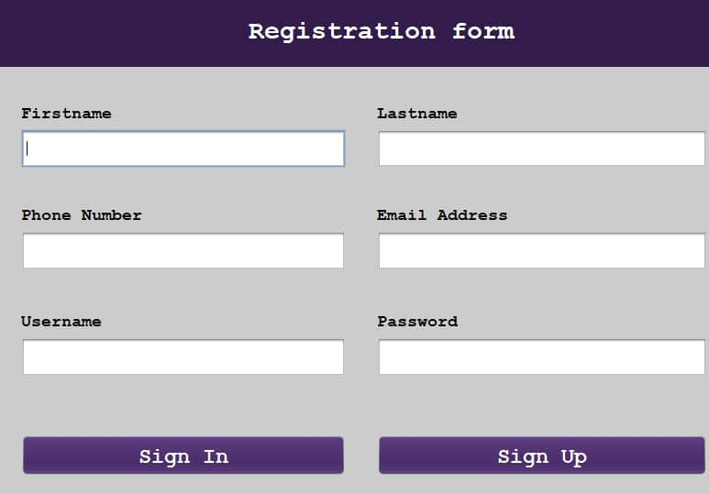

**After creating account means that you are a user of system so there a login form helps user to inter in the system by adding username and password he/she used in registration form.**

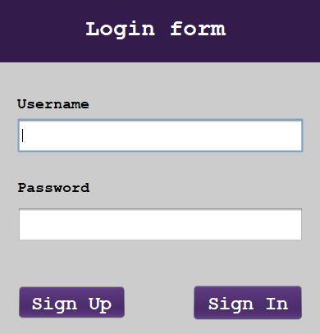

**This is a first menu of a system called MY WALLET that shows a user the amount of money he/she have on account. and also a user used it to check balance.**

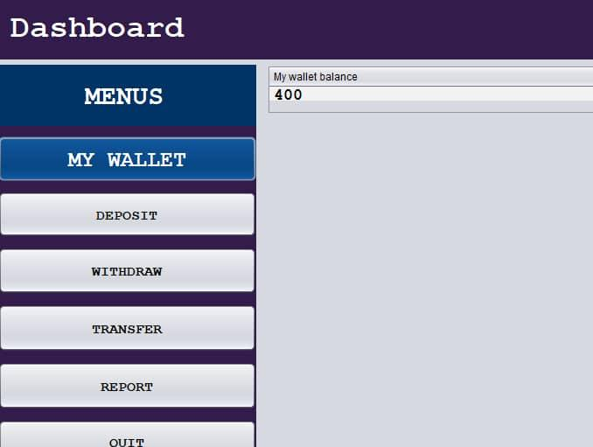

**This is a second menu of a system called DEPOSIT used for depositing money or adding money on account.**

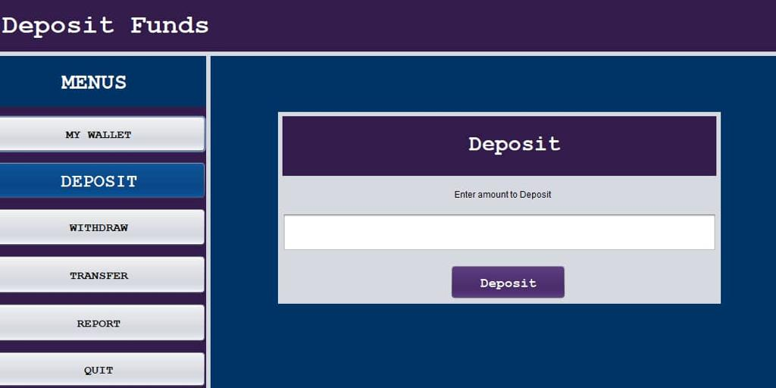

**This is a third menu called WITHDREW used for removing money on account or withdrawing money that are on the account.**

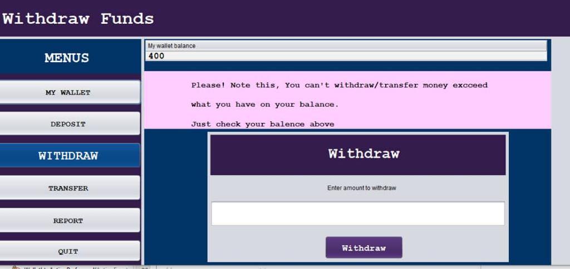

**This is a forth menu of a system called TRANSFER used for transferring money to anather place you want.**

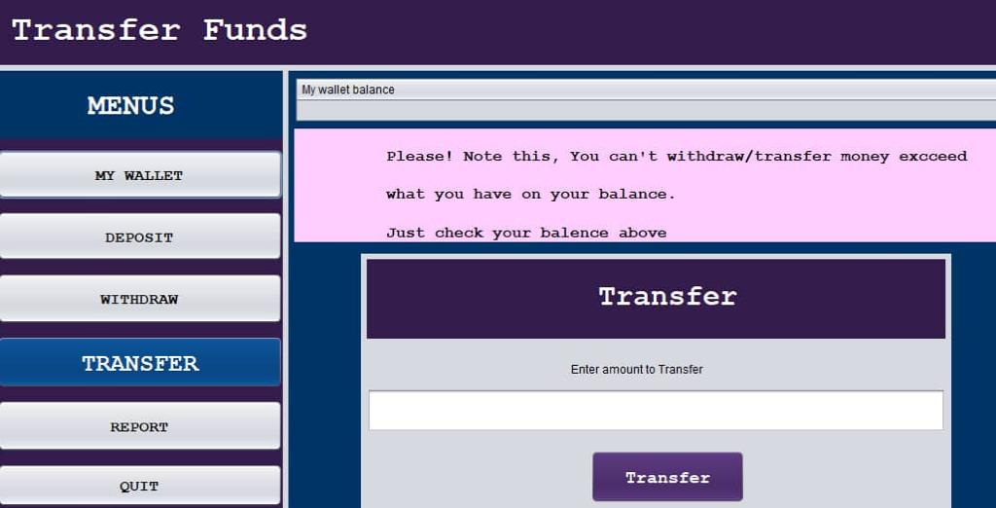

**This is a fifth menu of a system called REPORT this menu shows all details done.**

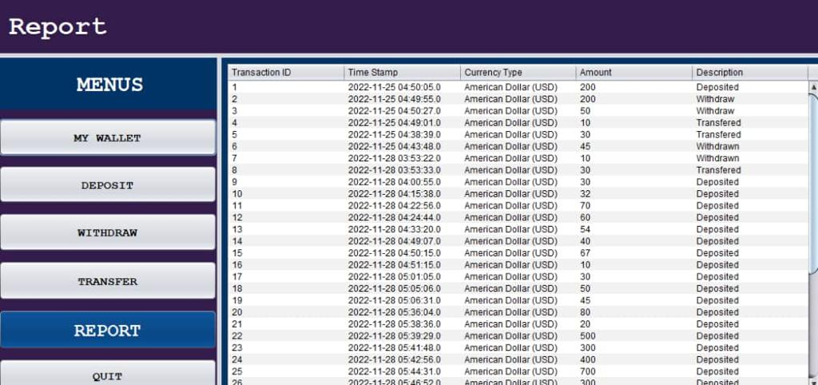

**The last one is QUIT that used to logout the system**

1. **DEVELOPMENT**

**How I build my entire system(front end-backend technologies), chosen libraries, platforms, storage and databases, adopted technologies are:**

* I developed my project e wallet backend and frontend parts by using java programming language called **net beans IDE.**
* For backend part I used MYSQL as Database management system to store data of system.
* For frontend parts, I used swing control generation from net beans to create tables, labels, and buttons for designing user interface.
* by using java programming language syntaxes I create interaction between user interface components such as buttons, forms .
* we used com.mysql.jdbs_5.1.5.jar as a library for handling MYSQL connection with the system

1. **TESTING**

**The way this stage was conducted. Ensuring that everything works as expected. and debug i found, and how did I fixed them to ensure that the product meets the origin specification**

* First open a project in apache net beans
* Second open XAMP server to start MYSQL
* Run sign in page
* Full fill registration form for being a user of a system (first name, last name, phone number, email address, username and password) and after full fills all those information sign in.
* Enter a user name and password you used when you registered to login in the system. If username and password doesn’t match as used before you will not get in ,but if it match you will get a welcome message
* After login a user will see six menus such as my wallet, deposit, withdraw, transfer, report and quit.

**My wallet:** This show a balance of money user has on wallet.

**Deposit:** here on this menu a user enter amount of money he/she needs to deposit on his wallet and click on deposit button to confirm transaction that money added.

**Click MY WALLET button to back to the landing page**

**withdraw:** here on this menu a user enter amount of money he/she wants to get according to his/her wallet and then click withdraw button confirm transaction.

**Click MY WALLET button to back to the landing page**

**Transfer:** here on this menu a user enter amount of money he/she needs to transfer according to his/her wallet and then click transfer button to confirm transaction.

**Click MY WALLET button to back to the landing page**

**Report:** this menu shows all details of transaction done by user such as transaction id, time stamp, currency type, amount and description.

**Click MY WALLET button to back to the landing page**

**Quit:** here this button will allow user to logout his account.

1. **DEPLOYMENT**

**How installation, testing, deployment and performance monitoring were conducting in my own respective laptop or desktop are:**

* Installing MYSQL as database management system for connecting java programs and database.
* Download and configure com.mysql.5.1.5.jar as library handling MYSQL connection. Use portable storage device to transfer project from development computer to the any library’s librarian computer.
* run a project for starting to use system.